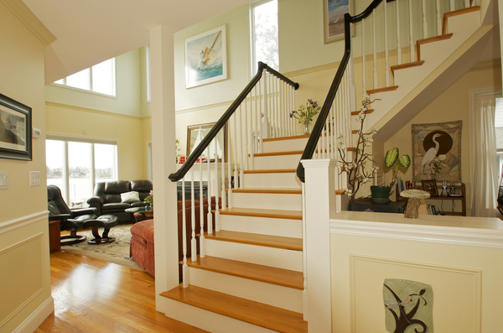

31 Dennison St., Gloucester
Owner/broker Broker | Gael D. Meyer | Style | Contemp. | Price | $1,3500
Age | 6 years old | Lot Size | 6,531 | Taxes | $6,803.75
Rooms | 10 | Bedrooms | 3-4 | Baths | 3
Garage | no | Living Area | 2,200
Assessment | $558,600 | Zoning | R-20

Room | Size Approx. | Floor | Eat-in-kitchen |  | Yes/island |  |  | Heat 2 zone |  | FHW gas/elec.
Living Room-HW | 16.6x13 | 1 | Cabinets-white |  | Custom |  |  | Cost
Dining Room-HW | 10.8x9 | 1 | Dishwasher |  | double |  |  | C/A- no |  | custom fans
Kitchen-HW  Library | 13.8x11  9.6x8 | 1  1 | Trash Compactor |  | Yes |  |  | Hot Water |  | Gas
Master Bedroom-HW | 13.7x12.3 | 2 | Stove-gas |  | Double oven |  |  | Floors |  | HW & Tile
Bedroom-HW | 12.6x10.3 | 2 | Refrigerator |  | stainless |  |  | Fireplace- |  | 2 Gas
Bedroom-HW | 9.9x7.8 | 1 | Washer/Dryer |  | HU |  |  | Deck |  | Large & small
Bath- master | 13x8.9 | 2 | Foundation |  | FS&concrete |  |  | Paved Street |  | Yes
Bath & Laundry-tile | full | 1 | Storm Windows |  | Anderson |  |  | Parking |  | 6 car-2 drive.
Blue Stone Patios | two |  | Storm Door |  | Yes |  |  | Water |  | City
Home office-HW | 11.2x7.8 | 1 | Siding |  | Clap |  |  | Sewer |  | City
Guest Suite/bedroom | 23x15 | LL | Sump |  | Yes |  |  | Fence |  | some
Bath | full | LL | Basement- YES |  | Walk Out |  |  | Smoke Alarm |  | Yes
Owner | On Record |  | Book | 23863 |  | Page | 78
Remarks: WATERFONT with Dock. Stunning Contemporary with open floor plan. Flowing staircase, Cathedral ceiling, HW and Tile floors. Water views from almost every room. Paneling, upgraded lighting, recessed lighting, wooden doors with upgraded knobs, fans, granite and stainless kitchen, Gas FP with custom mantel, Glass doors, atrium doors, huge deck overlooking water and dock, romantic master bedroom with private deck. Master bath you will love to come home to!! My favorite room. Glass shower multi heads, 6 foot air tub-gorgeous! Lower level walk-out with finished guest suite. Two bluestone patios. Professionally landscaped complete with stepping stones. A place to call home! Second home or first, or rent out in the summer for about $50,000. Sunsets, breezes, and birds! Heaven!
Buyer to assume water and sewer betterment fee.
Room sizes to be checked for accuracy. This is incomplete listing information and is for marketing purposes only. Additional and amplifying information is contained in the Seller’s Statement available from the listing office and should be referred to. All listings submitted on this page are subject to errors & omissions and it is the responsibility of the Buyer to verify this information by a competent home inspector. Offered to qualified Buyers regardless of race or nation origin.
MEGAN’S LAW. If the presence of a registered sex offender is a matter of concern to Buyer, Buyer understands that Buyer must contact local law enforcement officials regarding obtaining such information.

